HISHAM HAMED, individually,  and derivatively on behalf of  SIXTEEN PLUS CORPORATION,  Plaintiff,  v.  FATHI YUSUF, ISAM YOUSUF and JAMIL YOUSUF  Defendants,  and  SIXTEEN PLUS CORPORATION,  a nominal Defendant. | Case No.: SX-2016-CV-00650  DERIVATIVE SHAREHOLDER SUIT, ACTION FOR DAMAGES AND CICO RELIEF  JURY TRIAL DEMANDED

NOTICE OF HISHAM HAMED’S
SIXTH RULE 26 SUPPLEMENTAL DISCLOSURE

COMES NOW Plaintiff Hisham Hamed and provides NOTICE of the following supplementation of initial disclosures pursuant to Rule 26. In preparation for the upcoming depositions of the Defendants in this matter, Hamed discloses the following:
- Plaintiff Hamed has repeatedly offered counsel for Defendants, Isam Yousuf and Jamil Yousuf, the government’s disclosure documents, access to those documents and delivery of those documents provided to criminal defendants in the related criminal action. See Hamed’s Fourth Rule 26 Supplemental Disclosure, dated October 29, 2022. (Detailing efforts to provide the subject documents.)
- Out of an abundance of caution, Hamed now, further, discloses that he may use a number of those documents in the future prosecution of this matter—and may use such documents to examine witnesses in the upcoming depositions.
- As an example, because Fathi Yusuf has invoked his Fifth Amendment right against self-incrimination here, Hamed will seek to show Yusuf’s inability, based on his actual income, to have deposited large sums of his own funds (as described below) in his bank account on St. Martin (“Fathi BFC Account”).
- To do so, Hamed will examine witnesses with regard to:
- That Social Security Statement dated January 22, 2001, with regard to the account of FATHI Y. MOHAMAD YUSUF, (SSN xxx-xx-xxx3 and xxx-xx-xxx5) as the same was provided by the government in the criminal action by serving it on defense counsel for Fathi Yusuf and Waleed Hamed as part of the RP production, identified on the first page as document number 254-0745. That document indicates Yusuf’s income from 1965 up to 1999 as being [REDACTED] and his income from 1995 through 1997 as being [REDACTED], as follows:

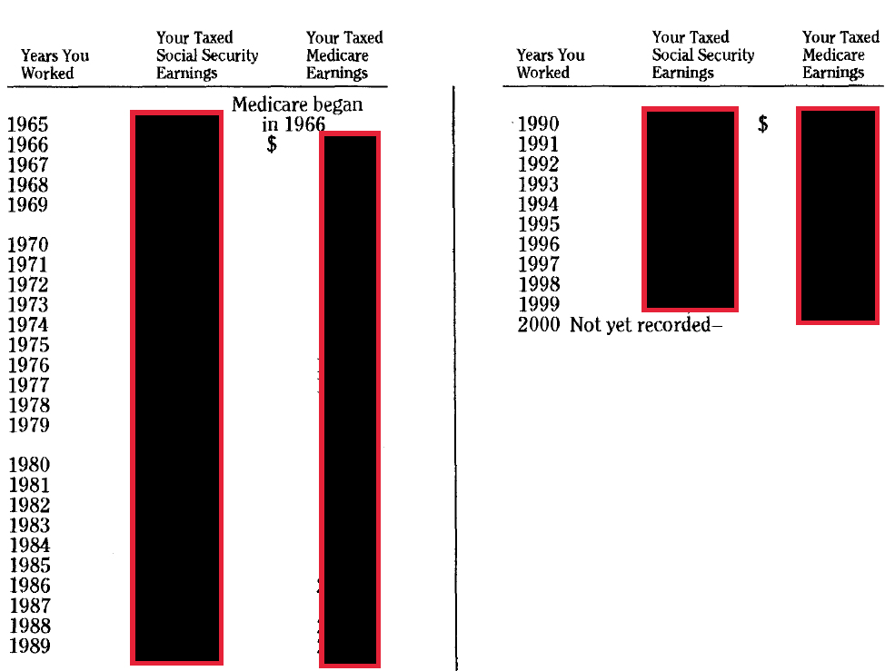
- Similarly, the STM BFC bank account statements of Fathi Yusuf supplied in the criminal matter show that he deposited [REDACTED] in 1996. For example, In June 1996, the BFC statement for Fathi Yusuf’s account (xxxxxxx77) shows 3 deposits totaling $95,000 The third page shows one of the deposit slips indicating five-hundred (500) $100 bills ($50,000). This document was similarly supplied by the government as shown by the Bates Stamp on the left border:

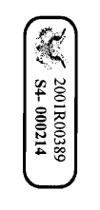
- Thus, Hamed makes it clear that he has met his Rule 26 disclosure requirements by his full disclosure and the now-expired proffer of these documents and may, therefore, utilize such documents in the examination of witnesses, the examination of corporate entities or filings herein without any further notice.

Counsel for Hisham Hamed

Dated: December 7, 2022 A
Carl J. Hartmann III, Esq. (Bar #48)
Co-Counsel for Hisham Hamed
2940 Brookwind Dr,
Holland, MI 49424
Telephone: (340) 642-4422
Email: carl@carlhartmann.com

Joel H. Holt, Esq. (Bar # 6)
Counsel for Hisham Hamed
LAW OFFICES OF JOEL H. HOLT
2132 Company Street,
Christiansted, Vl 00820
Email: holtvi@aol.com
Phone: (340) 773-8709/
Fax: (340) 773-8677

CERTIFICATE OF SERVICE

I hereby certify that this document complies with the page and word limitations set forth in Rule 6-1(e) and that on December 7, 2022, I served a copy of the foregoing by email and the Court’s E-File system, as agreed by the parties, to:

James Hymes III, Esq.

Counsel for Defendants Isam and Jamil Yousuf

LAW OFFICES OF JAMES L.

HYMES, III, P.C.

P.O. Box 990

St. Thomas, VI 00804-0990

Tel: (340) 776-3470

Fax: (340) 775-3300

jim@hymeslawvi.com

Charlotte K. Perrell, Esq.

Stefan B. Herpel, Esq.

Counsel for Defendant Fathi Yusuf

DUDLEY NEWMAN

FEUERZEIG LLP

Law House

1000 Frederiksberg Gade

P.O. Box 756

St. Thomas, VI 00804-0756

Tel: (340) 774-4422

cperrell@dnfvi.com,

sherpel@dnfvi.com

Kevin A. Rames, Esq.

Counsel for Nominal Defendant

Sixteen Plus Corporation

2111 Company Street, Suite 3

Christiansted, VI 00820

Phone: (340) 773-7284

Fax: (340) 773 -7282

kevin.rames@rameslaw.com

/s/ Carl J. Hartmann

After repeated efforts, counsel for the Yousufs has continued to refuse the proffer, and that proffer has long expired. Hamed has noted that these documents may also be obtained from Fathi Yusuf’s counsel. Yusuf has an identical set.
This is not intended to make matters more difficult or complicated for the Yousufs’ counsel—rather, it is simply too difficult to trace, track and monitor which documents their counsel may or may not have elected to receive and review, and then make special service prior to use.

